

NAME: D DEVISRI PRASAD
REG NO:192425221
COURSE CODE: MLA0214
COURSE NAME: FUNDAMENTAL OF MACHINE LEARNING

Experiment 14: House Price Prediction

Question
Implement House price Prediction using appropriate machine learning algorithm.

Aim
To predict house prices using Linear Regression.

Algorithm
- Import libraries
- Create dataset
- Split dataset
- Train model
- Predict house prices

Python Code
from sklearn.linear_model import LinearRegression
from sklearn.model_selection import train_test_split
import numpy as np
X = np.random.rand(300,4)*50
y = X[:,0]*300 + X[:,1]*200 + X[:,2]*100 + X[:,3]*50
X_train,X_test,y_train,y_test = train_test_split(X,y,test_size=0.2)
model = LinearRegression()
model.fit(X_train,y_train)
pred = model.predict(X_test)
print(pred[:5])

Output Screenshot
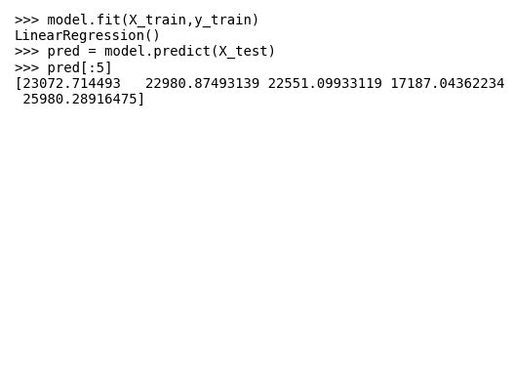

Result
House price prediction model executed successfully.

